Order No:163/2026
Dated: 03-01-2026

Subject: Partial Modification to Order No. 102 of 2025 dated 29-09-2025 regarding Assignment of Store Incharges and Associated Responsibilities.

In partial modification to this office Order No. 102 of 2025 dated 29-09-2025, it is hereby ordered that Mr. Adnan Saied, Multi-Tasking Staff (MTS), shall assist the Store Incharges in all store-related activities in place of Mr. Arif Ali Zargar, Workshop Assistant, with effect from the date of issuance of this order.
All concerned Officials are directed to comply with this order accordingly.

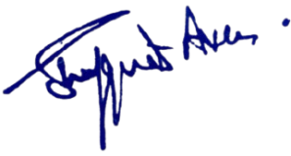

No: KGP/Estt/2025-26/1905
Dated:03-01-2026

Enclosure: Order Copy 102 of 2025
Dr. Shafquat Ara
Principal
Kashmir Govt.Polytechnic College Srinagar

Copy to the:
1.All concerned for information and compliance.

